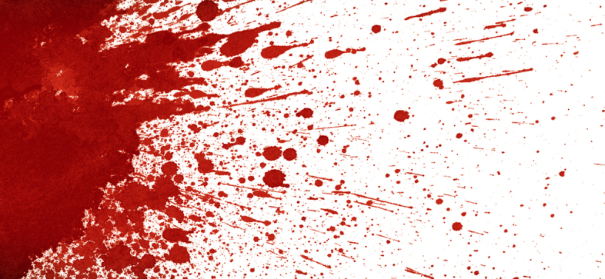

Blood Splatter Analysis Lab

Introduction

One technique used by crime scene investigators is the analysis of stains left by blood shed at crime scenes. If a scientist understands the dynamics of how blood behaves when it exits the body and how it reacts when it contacts a surface, then an attempt can be made to understand the circumstances behind the presence of the blood spatter and to determine whether a crime has occurred. As a trained scientist, you will look at patterns of shed blood, measurement of blood droplets and drawings or photographs of potential crime scenes to determine what may have occurred. Blood stains cannot always be moved back to the lab so it is important that you keep good records of all of the evidence that you find at the scene.

The shape of a blood drop can indicate the distance from which the blood fell and the angle of its impact. Very few studies have been done to determine the patterns that blood makes as it impacts a surface. Therefore, a thorough scientist will conduct investigations to collect their own data regarding shape of blood droplets. When a droplet is falling, it is primarily spherical in shape, and the smaller the drops, the more spherical their shape will be during the fall.

If you examine a blood droplet that has struck a surface at a 90 degree angle from the surface, the droplet is generally round. Straight-on impacts on hard, smooth surfaces produce round droplets with smooth edges.

Higher velocity impacts or impacts on rougher surface produce drops with more ragged edges. Drops with ragged edges have fallen at high velocities. Drops that fall at angles greater than 90 degrees are elongated in shape.

Blood droplets can be produced in several ways. A droplet that forms slowly, as from a dripping wound, has a volume of roughly 0.05 ml. Smaller droplets are produced during active situations, such as fights or beatings. Blood drops that appear to have come from an aerosol spray have come from a powerful force such as a gunshot or an explosion.

Now you will generate your own set of blood spatter patterns that you can compare to evidence found at a crime scene.

Supplies

Dropper bottle or plastic pipette
Source of simulated blood
Ruler/meter stick
Index cards
Plastic knife
Long sheet of butcher paper
10 mL plastic graduated cylinder
Cleaning supplies

1. Simulating Blood Droplet Patterns From Various Heights

Develop a data table, and graph, to demonstrate the relationship between height of a blood drop and diameter of blood drop (measured in mm) using your paper or index card. Include a column in your table to include a sketch of the blood drop. Make sure to cover a logical range of heights so a full picture of the relationship can be seen and include at least 8 data points in your graph.

Analysis: What is the overall trend seen here?

2. Simulating Multiple Blood Drop Patterns

Using a dropper, from a height of 30 cm, drop a single drop of blood onto your paper or index card. Making a data table, include a sketch of this one blood drop. Repeat this process up to 4 drops of blood. Finally, making sure to be as clean as possible, use 2-3 mL of simulated blood and empty the entire volume onto the paper.

Question: what conclusions and observations can you draw from this simulation?

3. Simulation of Blood Cast-Off Patterns

Spread a long sheet of paper on the floor. Dip your plastic knife into the simulated blood. Holding the knife at a height of 30 cm, walk across the paper slowly swinging your arm. Allow the knife to drip as you walk. Using a data table, draw and label the pattern this generates. Repeat this from a height of 60, 90 and 120 cm.

Analysis: What is the overall trend seen here?

4. Speed of Movement

Walk across your long sheet of paper at 3 different speeds while dropping blood at a constant speed onto the paper. Prepare a data table to demonstrate the relationship between walking rate and size, shape and distance between drops at each speed, making sure to include a sketch of the data obtained. Measure the rate of speed (in m/s) as accurately as possible.

Question: What did you notice about the shape of the drops as you increased your walking speed?

Question: What did you notice about the spines as you increased your walking speed?

5. Angle of Impact

Answer the question: “how does the angle of impact of a drop of blood influence its length?” Using a data table, obtain all relevant data and create a graph illustrating the relationship between angle of impact and length of blood drop (measured in cm). To do this, use a blank piece of paper and rest it on a book, using a protractor (provided) to measure the angle of impact.

Analysis: What is the general relationship seen between angle of impact and blood drop length?
6. Direction of Travel

You have probably noticed by this point that the elongated end of the blood drop points in the direction of travel. Using trigonometry, and the equation provided, create a data table of blood drops striking a surface with at least 5 impact angles. Record the width and length of the drop, eliminating the tail from the length measure, in cm. In the same table, use the following equation to calculate the impact angle and compare it with the measured angle:
$$impact angle=\sin^{-1}\frac{drop width}{drop length}$$

Additionally, determine the percent error of your calculated impact angle to the measured angle, using the following equation, and add it to your table:
$$\% Error= \frac{calculated-measured}{measured} × 100\%$$

Analysis: Overall, how close did your calculations come to the measured angle of impact? What was your average percent error?

7. Origin of Blood Source

This is probably the hardest procedure of them all. Have a partner put simulated blood on their gloved hands and clap at an unknown height above your paper. This will create multiple blood drops radiating from the origin of the blood spatter. You can locate this origin by triangulation. To do this, determine the direction of travel (see above procedure) for multiple blood drops on various sides of the spatter pattern. Using string, determine the angle of impact and stretch the strings to the point where they converge. You can secure the converging strings to a ring stand that will approximate the origin.

Analysis: Were you successful in approximating the origin of the blood source?

8. Left- or Right-Handedness

Have a right-handed student stand near a wall covered with paper. Dip a plastic knife in simulated blood and rapidly pull the arm back and forth toward the wall. This will simulate thrusting the knife into a victim. Repeat with a left-handed student.

Analysis: How does the cast-off pattern vary for different handed individuals?

Finally…

Simulate a crime scene on a large sheet of paper. Bring in another individual or group and see if they can tell the “story” of what happened using only the blood evidence provided.

Teacher Notes

Blood recipe: 240 mL Corn syrup, Lots of red food coloring, a little green, some chocolate syrup

